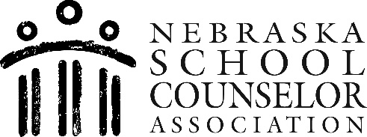
2024 Scholarship Application
A scholarship competition for any high school senior in support of their post-secondary education.

Guidance Counselor vs School Counselor
In 1990, the American School Counselor Association (ASCA) officially requested that the profession move away from the term “guidance counselor” which emphasized vocational guidance only, and adopt the term “School Counselor,” to better illustrate the professional scope of their role.

The Role of a School Counselor
School counselors are certified/licensed educators who address the needs of ALL students by implementing a comprehensive school counseling program. School Counselors help students apply academic achievement strategies, help students manage emotions and apply interpersonal skills, address equity and access issues, assist with increasingly complex social challenges, and help students with career and post-secondary planning (higher education, military, work force).

NSCA Scholarship Eligibility/General Guidelines
- Student must be a high school senior attending a public or private-secondary school in Nebraska.
- Student must attend an accredited post-secondary institution during the 2024-25 school year.
- Recommending Counselor must be a current NSCA (Nebraska School Counselor Association) member
- Student must have a current weighted GPA of 2.5 or greater
- If selected, you will be asked to email a digital photo of yourself to the committee.

DETAILS
- Awarded scholarship will be paid directly to the higher education institution.
- Three (3) scholarships will be awarded in the amount of $500 each, one to each of the following school types: Class A, Class B, Class C/D (Based on high school’s Track and Field classification)

Deadline: Entries must be postmarked no later than February 15, 2024
- Scholarship awardees will be announced in April 2024

APPLICATION PROCEDURE
- Compose a one (1) page essay of no more than 500 words, about any K-12 School Counselor who has made a difference in your Academic, Career/Post-Secondary and/or Social-Emotional development.

- Essays must be typed and double-spaced. Do NOT put your name, your counselor’s name, or the name of your high school in/on the essay. Failure to follow these guidelines will disqualify the applicant from consideration.

- Send one (1) copy of your essay, and the completed application form to:
Nebraska School Counselor Association Attn: Scholarship Committee
P.O. Box 540153
Omaha, NE 68154
NOTE: Incomplete applications will not be scored. Please provide ONLY the materials stated above.
Please do not place materials in folders or report covers. Do not staple materials.

* Applicants not providing the required documents OR providing additional documents not requested may be disqualified from the award process.

(For NSCA Scholarship Committee use ONLY) School Class ID#

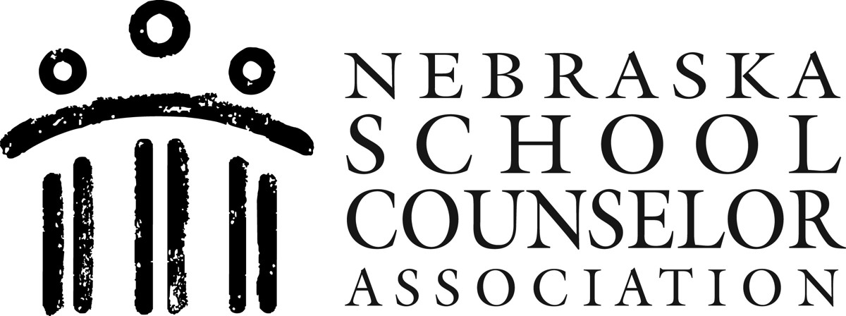

2024 Nebraska School Counselor Association Scholarship Application
Deadline: Entries must be postmarked no later than February 15, 2024 Please PRINT or TYPE:
Student Name:
First Middle Last
High School Name:

Student Address:

Student Email Address:

Student Phone:

By signing below, I hereby certify that the essay I am submitting is my own work. I further understand that, once submitted, it becomes property of the Nebraska School Counselor Association (NSCA). I grant permission to NSCA to publicize my name, picture, school, and essay.

Student Signature: Date:

Parent Signature (if student is under age 18)

FOR SCHOOL COUNSELOR USE ONLY
School class size (based on high school’s Track and Field classification):

Class A Class B Class C/D Student’s Weighted GPA
By signing below, I verify that I am a current member of the Nebraska School Counselor Association (NSCA).

School Counselor name (printed):

School Counselor Signature: Date:

Questions may be directed to Diane Fogleman, NSCA Scholarship Committee Chair, at fogleman3@cox.net or Katie Cameron, katie.cameron@neschoolcounselor.org

